**Microprocessor Lab  
Lab Experiment No. 2**

Name: Ninad Rao Roll No. 53

**Aim**: Realization of half adder and full adder.

**Half Adder**: The Half-Adder is a basic building block of adding two numbers as two inputs and producing two outputs. The adder is used to perform OR operation of two single bit binary numbers. A and B are the two input bits, and 'CARRY' and 'SUM' are two output states of the half adder.

Below are the logic diagram and block diagram of Half Adder respectively:

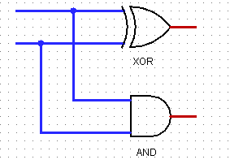 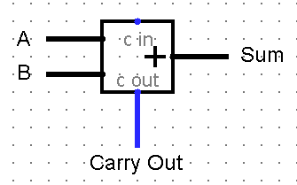

This is called Half Adder because with two inputs, it cannot consider the carry of the previous stage. Thus Half Adder is always used for LSB addition with no carry inputs forwarded.

**Half Adder is required for**:

1. The ALU (Arithmetic Logic Circuitry) of a computer uses half adder to compute the binary addition operation on two bits.
2. Half adder is used to make full adder as a full adder requires 3 inputs, the third input being an input carry i.e. we will be able to cascade the carry bit from one adder to the other.
3. Ripple carry adder is possible to create a logical circuit using multiple full adders to add N-bit numbers. Each full adder inputs a C-IN, which is the C-OUT of the previous adder. This kind of adder is called Ripple Carry Adder, since each carry bit "ripples" to the next full adder. Note that the first full adder (and only the first) may be replaced by a half adder.

**Components required:** In Half Adder, it adds two binary digits where the input bits are termed as augend and addend and the result will be two outputs one is the sum and the other is carry. To perform the sum operation, XOR gate is applied to both the inputs, and AND gate is applied to both inputs to produce carry.

**Circuit Diagram**: Here is the circuit diagram of half adder using basic gates.

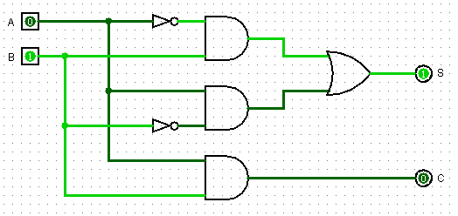

Where, A and B are the inputs given to the Half adder

S (Sum) and C (Carry) are the outputs of Half Adder

**Working of Half Adder**: Half Adder is a combinational arithmetic circuit that adds two numbers and produces a sum bit (S) and carry bit (C) as the output.

When both inputs are LOW then sum and carry will be logic LOW. If any one input is HIGH then Sum will be logic HIGH and carry will be logic LOW. When both inputs are HIGH then Sum becomes logic LOW and Carry becomes logic HIGH.

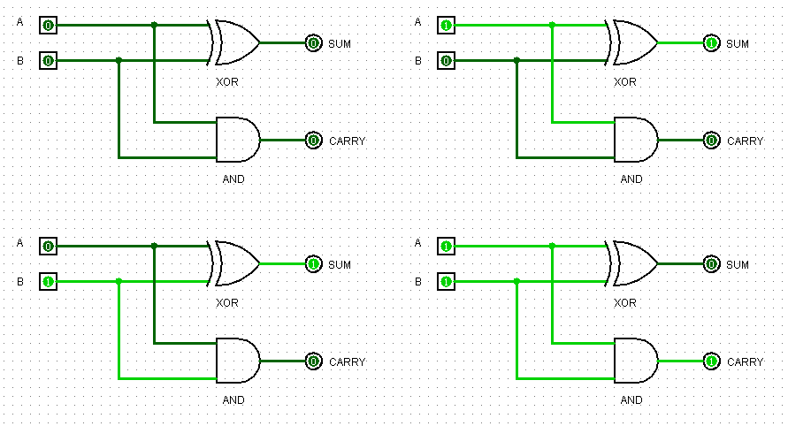

**Statement for Half Adder:**

Sum = A' . B + A . B'

Carry = A . B

**Truth Table**:

|  |  |  |  |
| --- | --- | --- | --- |
| **A** | **B** | **C (Carry)** | **S (Sum)** |
| 0 | 0 | 0 | 0 |
| 0 | 1 | 0 | 1 |
| 1 | 0 | 0 | 1 |
| 1 | 1 | 1 | 0 |

**Full Adder**: Full Adder is the adder which adds three inputs and produces two outputs. The first two inputs are A and B and the third input is an input carry as C-IN. The output carry is designated as C-OUT and the normal output is designated as S which is SUM.

Below is the block diagram of Full Adder:

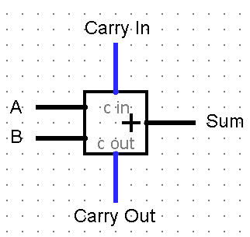

Full Adder is like 3 input adders which can generate the sum and carry.

**Full Adder is required for**:

1. Full Adder can be a part of Ripple carry adder which adds n-bits at a time. Ripple carry adder is possible to create a logical circuit using multiple full adders to add N-bit numbers. Each full adder inputs a C-IN, which is the C-OUT of the previous adder. This kind of adder is called Ripple Carry Adder, since each carry bit "ripples" to the next full adder.
2. The ALU (Arithmetic Logic Circuitry) of a computer uses full adder to compute the binary addition operation. It can be used for carrying out Multiplication, the dedicated multiplication circuit uses it.
3. Full Adder is used to generate memory addresses inside a computer and to make the Program Counter point to the next instruction, the ALU makes use of this adder.
4. For graphics related applications, where there is a very much need of complex computations, the GPU uses optimized ALU which is made up of full adders, other circuits as well

**Components required:** A full adder adds binary numbers and accounts for values carried in as well as out.To perform the sum operation, it includes two EX-OR gates, an OR gate, and two AND gates for its inputs and outputs.

**Circuit Diagram**: Here is the circuit diagram of full adder using basic and EX-OR gates.

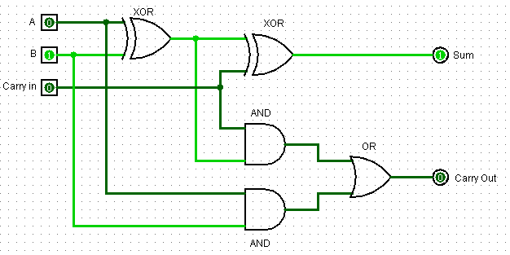

**Working of Full Adder**: Full adder is a combinational circuit, which performs the addition of three bits A, B and C-IN. Where, A & B are the two parallel significant bits and C-IN is the carry bit, which is generated from the previous stage.

When both inputs are LOW then sum and carry out will be logic LOW. If any one input is HIGH then sum will be logic HIGH and carry out will be logic LOW. When two inputs are HIGH then sum becomes logic LOW and carry out becomes logic HIGH. When all inputs are HIGH the output sum and carry out will be logic HIGH.

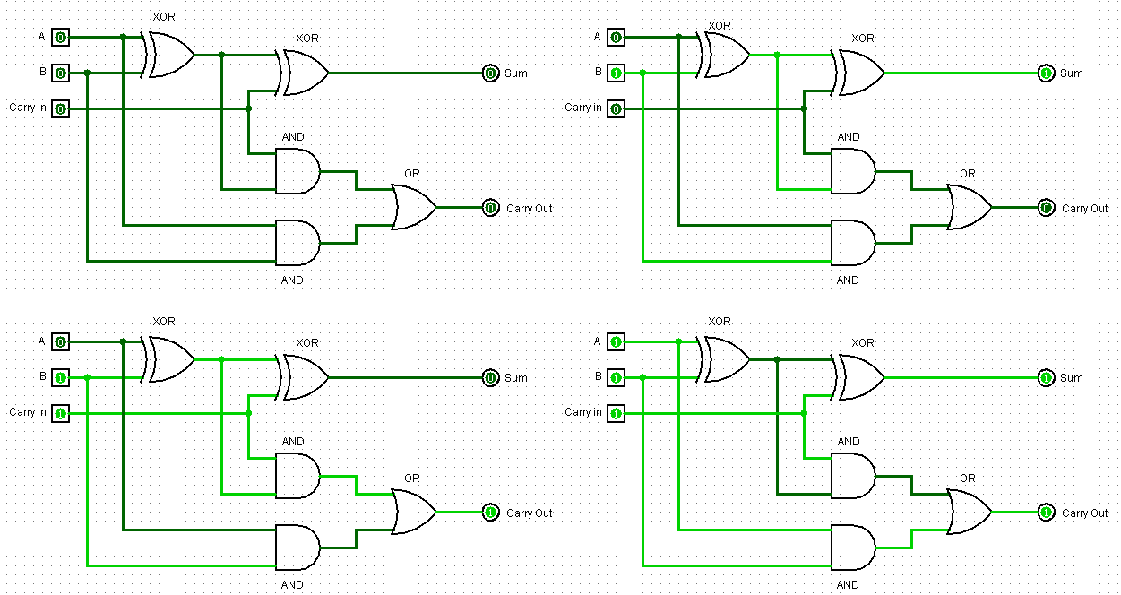

**Statement for Full Adder:**

Sum = A' . B' . C + A' . B . C + A . B' . C' + A . B . C

Carry = A . B + A . C + B . C

**Truth Table**:

|  |  |  |  |  |
| --- | --- | --- | --- | --- |
| **A** | **B** | **Carry In** | **Sum** | **Carry Out** |
| 0 | 0 | 0 | 0 | 0 |
| 0 | 0 | 1 | 1 | 0 |
| 0 | 1 | 0 | 1 | 0 |
| 0 | 1 | 1 | 0 | 1 |
| 1 | 0 | 0 | 1 | 0 |
| 1 | 0 | 1 | 0 | 1 |
| 1 | 1 | 0 | 0 | 1 |
| 1 | 1 | 1 | 1 | 1 |

**Selection of IC’s for Half Adder and Full Adder**:

**IC for Half Adder**: Here XOR gate IC 7486 and Logic AND gate IC 7408 are used to construct the half adder circuit, both are quad 2 input logic gate IC.

**IC for Full Adder**: Here XOR gate IC 7486 and Logic AND gate IC 7408 and OR gate IC 7432 are used to construct the full adder circuit, both are quad 2 input logic gate IC.

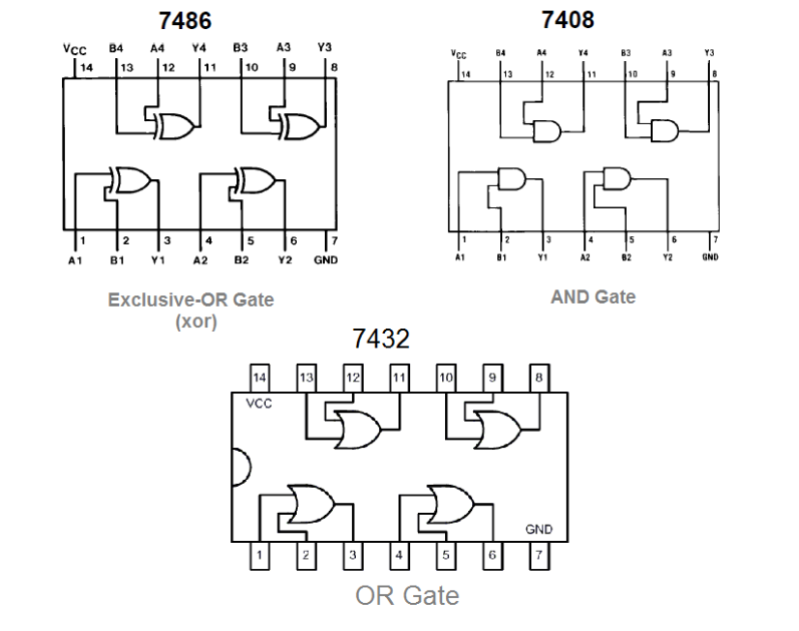

**Conclusion**: Thus, we have studied and understood the realization of Half Adder and Full Adder.